- List of weborder screen
Presently, user have to allocate “PR” product manually in each weborder, it is time-consuming and tedious for user to click every weborder to check is there PR items. Would like to request IT to use colours (any colours other than pink) to indicate that the weborder consist of PRxxxxx items. This will help user to know which weborder to allocate at one glance. Below is an example.

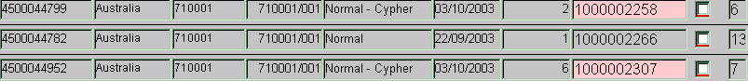

- Pick Ticket consolidation
User is able to filter by “ship to “ code when generating / consolidating pick ticket, however, problem arises when there is cypher allocation and cordis allocation. When a “ship to” code is being select, it might consist of both Cypher and Cordis allocation, user will normally noted down manually which is cordis and cypher.
Would like to suggest IT to add in one more column, to allow user to filter “cypher” or “cordis”

This will help user to reduce generating pick ticket time and also eliminate human error to combine both corids and cypher items together

